**Information Document: Update on the Development of a Global Knowledge Support Service for Biodiversity**

At COP 15, Parties adopted an ambitious package of decisions related to the Kunming – Montreal Global Biodiversity Framework. In accordance with COP decision 15/6, Parties have begun to [update their national biodiversity strategies and action plans](https://ort.cbd.int/national-targets) including national targets, aligned to the Global Biodiversity Framework, and are focused on implementation. Parties will need to monitor their national actions and scale up activities, as needed, to deliver their strategies by 2030. A first milestone will be delivery of 7th national reports, by 28 February 2026, using indicators from the monitoring framework. A **global knowledge support service for biodiversity** could be a valuable tool to enable Parties to gain access to dispersed sources of data, information, and knowledge, as well as tools and networks, to support the planning, implementation, monitoring, review and reporting of progress towards NBSAPs aligned to the Global Biodiversity Framework.

**Background and context**

The Kunming-Montreal Global Biodiversity Framework and an ambitious package of decisions supporting its implementation was adopted at the 15th meeting of the Conference of the Parties to the Convention on Biological Diversity (CBD COP15) in December 2022. Throughout the negotiations of the Global Biodiversity Framework and of the associated monitoring framework, Parties noted the need for capacity-building, and technical and scientific cooperation to, *inter alia*, enhance the generation, collection, assessment, access to and effective use of data, information, and knowledge to support strengthened national capacity for implementation, as well as enhanced transparency on progress being made towards its ambitions. Capacity-building and development needs are described in document CBD/COP/16/INF/24, and capacity gaps identified by Parties specifically in relation to the use of the monitoring framework are summarised in document CBD/COP/16/INF/4 (Section 2).

Since 2022, UNEP-WCMC[1] and partners have been exploring the role of a **global knowledge support service for biodiversity** to build national capacity, and to enhance the delivery of knowledge to support the implementation of the Global Biodiversity Framework. Consultations with Parties and relevant stakeholders were held during side events at CBD COP15, and the 25th and 26th meetings of the Subsidiary Body on Scientific, Technical and Technological Advice (SBSTTA25 and 26), and during a co-design workshop in April 2023 in Cambridge, UK. The service was launched at CBD COP15, where Parties and stakeholders indicated their support and a need for the service. In decision 15/16, the Conference of the Parties took note of a global knowledge support service for biodiversity, notably for tracking progress on targets and goals of the Global Biodiversity Framework.

Needs expressed by Parties and stakeholders for accessible, up-to-date data, information, and knowledge to support implementation of the Global Biodiversity Framework are summarised in discussion documents about a global knowledge support service (Versions 1[2] and 2[3]). Following the initial assessment of needs and opportunities, the scope of the proposed global knowledge support service for biodiversity has been refined. A phased approach to development will initially aim to support Parties’ needs in relation to the monitoring, reporting and review of progress towards implementation of the Global Biodiversity Framework. The monitoring framework for the Global Biodiversity Framework includes indicators to measure progress towards its goals and targets. Implementation of the monitoring framework is essential for understanding progress towards the Global Biodiversity Framework at national and global scales, course-correcting where needed, and improving transparency and accountability of implementation. It is imperative that support is provided to Parties to enable them to use the indicators of the monitoring framework and other indicators subject to national needs, as part of the monitoring, review and reporting process for the Global Biodiversity Framework. A structured, signed-posted global knowledge support service for biodiversity will facilitate access to dispersed sources of data, information and knowledge and a range of materials and resources that can be used support monitoring at national levels.

Further context relates to the establishment of regional and subregional technical and scientific cooperation support centres (TSCCs), under Decision 15/8. Given that the purpose of the TSCCs is to promote and facilitate technical and scientific cooperation among Parties and relevant organizations to enable them to effectively utilize science, technology and innovation to support the implementation of the Global Biodiversity Framework, the TSCCs are key to the work of the global knowledge support service. The decisions that Parties make at COP16, relating to the TSCCs and the operationalisation of the global coordination entity for the technical and scientific cooperation mechanism[4] will inform the support services to be delivered via the regional and subregional technical and scientific support centres and the global knowledge support service.

The TSCCs and a global knowledge support service are referenced in the draft decision for Agenda Item 10 for COP16, on mechanisms for planning, monitoring, reporting and review (on the monitoring framework for the Kunming – Montreal Global Biodiversity Framework, para 32)[5] whereby, the potential role of a service to support the operationalisation of the monitoring framework, including by:

1. Sharing updates with Parties on the implementation of the monitoring framework on an ongoing basis, including information shared by multilateral environment organizations, members of the Biodiversity Indicators Partnership and other relevant organizations;
2. Identifying options and potential collaborators to address gaps identified by the Ad Hoc Technical Expert Group on Indicators, including for the development of headline indicators 1.1 and 9.1;
3. Facilitating capacity building and development activities related to the implementation of the monitoring framework at the national level.

**Principles of the global knowledge support service for biodiversity**

Key elements have emerged through the consultation process, including the need for the service to:

* be impartial;
* be cost-effective;
* be guided by Parties’ needs and the long-term strategy on capacity building and development to support national capacity development;
* strengthen national capacity for biodiversity data and knowledge sharing (including through supporting a network of actors, promoting automation, enhancing efficiencies in data aggregation and tracking progress, streamlining workflows, etc.);
* enhance accessibility of resources to key audiences through a single signposted platform;
* connect relevant networks and experts to provide support to Parties’ needs and/or provide support to TSCCs;
* strengthen national data governance for enhanced implementation and monitoring (including through promoting the creation of enabling policies and institutions);
* accelerate digital transformation strategies (including through undertaking digital readiness for biodiversity national assessments; facilitating partnerships with technology and data providers; and enabling peer to peer support and replication of good practice); and
* promote policies and standards to advance the interoperability of data and tools (including data sharing policies, aligned taxonomies, linked ontologies, automation and APIs[6], etc.).

**Types of support services[7] provided by the global knowledge support service for biodiversity**

In response to Parties’ request for support, there are three types of support service to be provided via the global knowledge support service for biodiversity, in the initial phase:

1. Online support – where dispersed information, guidance documents, various tools and training materials are made accessible including through supporting a network of actors, promoting automation and data-sharing, enhancing efficiencies in data aggregation and tracking progress, streamlining workflows, etc.).
2. Direct/ tailored support through a helpdesk or matchmaking service that connects Parties with members of the expert community, responding to the request for support from a network of actors.
3. Longer term support can be requested via the global knowledge support service, to participate in the [National Monitoring Support Initiative](https://www.international-climate-initiative.com/en/project/leveraging-the-biodiversity-indicators-partnership-to-strengthen-national-biodiversity-monitoring-systems-for-enhanced-implementation-of-the-post-2020-global-biodiversity-framework-22-iv-125-global-m-biodiversity-indicators-partnership/), which aims to build capacity for sustainable national monitoring systems. This responds to the request from Parties, to strengthen national capacity for biodiversity data, information and knowledge sharing.

**Linkages to other tools, resources, initiatives, and processes**

As noted, the global knowledge support service for biodiversity will primarily connect dispersed sources of data, information and knowledge as well as tools and resources that support national monitoring, reporting and review of implementation of the Global Biodiversity Framework. A range of tools, datasets, knowledge products, information resources and networks exist already, which can be used by Parties to enhance national monitoring, reporting and review of actions towards their NBSAPs and national targets (see figure 1). The service will provide guided access to resources subject to Parties’ needs and preferences. The service may also be able to highlight gaps in current knowledge and data, and signpost where further developments are required.

The aim of the global knowledge support service, in support of Decision 15/8, is to provide access to data, information and knowledge, and to support knowledge management and capacity building and development. Specifically, the service will support the implementation of the long-term strategic framework for capacity-building and development[8], and proposed activities under the knowledge management strategy to support the Kunming – Montreal Global Biodiversity Framework and the Knowledge Management for Biodiversity (KM4B) initiative[9] which aims to support implementation of Target 21 of the Global Biodiversity Framework. When decisions are made by Parties on the operational modalities for the regional and subregional scientific and technical support centres and the global coordination entity, the global knowledge support service will be designed to provide data, information and knowledge, either through information and knowledge flow to the support centres, or to a global coordination entity, as appropriate.

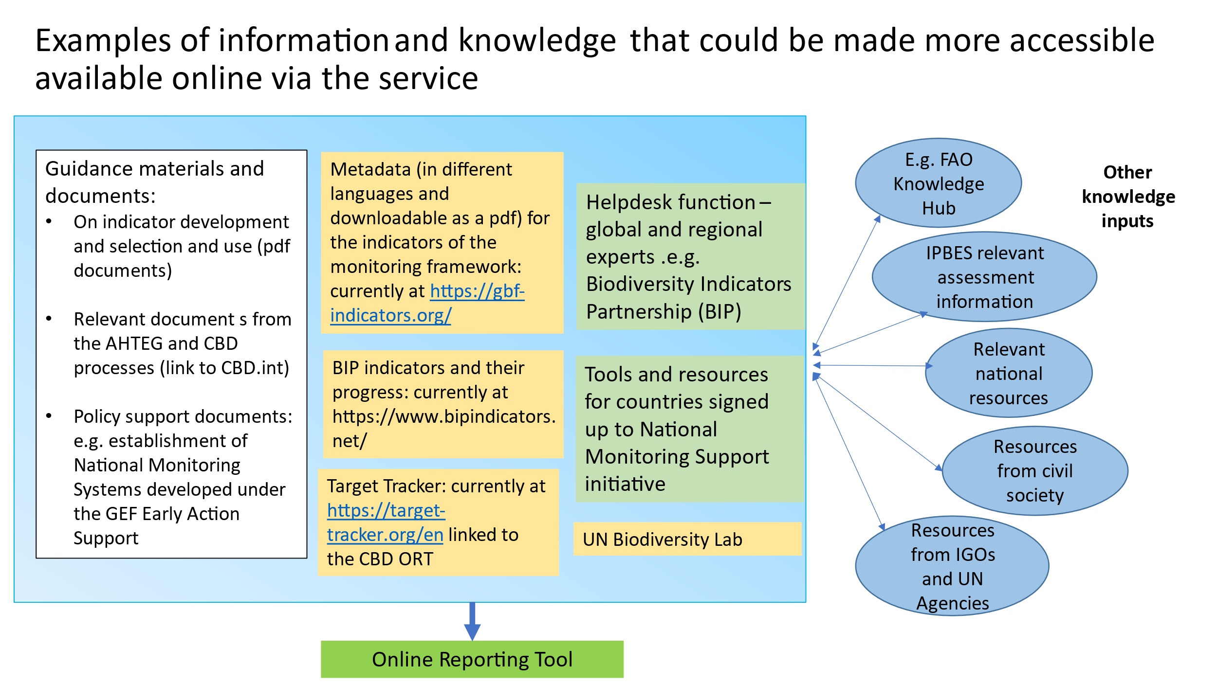

**Figure 1. Access to dispersed resources for monitoring and the global network of experts to provide knowledge and advice in response to needs.**

**Phases of development of the** **global knowledge support service**

The global knowledge support service for biodiversity is being implemented using a phased approach, allowing for adaptive implementation and linked to the availability of resources**.** The design of subsequent phases will benefit from feedback gathered from users during initial phases.

* In Phase 0 (2023 – 2024), the support service is organised and links to relevant resources on:
* CBD decisions and documents related to planning, monitoring, reporting and review
* Indicator selection and headline indicator metadata
* Monitoring resources
* Tools related to CBD reporting
* Relevant news items

See Annex 1 for more information on Phase 0 of the global knowledge support service, which in summary includes:

* **Updating the Target Tracker,** whichtracks progress towards the Global Biodiversity Framework at national and global levels, linked to the CBD Online Reporting Tool.
* **Developing a design-based prototype** for the online portal service, based on user research.
* **Establishing options for mechanisms to connect Parties** with the global and regional community of experts and technical and scientific support.
* **Developing a Roadmap** outlining the future direction of the service beyond COP 16.

Subsequent developments of the global knowledge support service for biodiversity, subject to the availability of resources, will be developed as follows:

* **Phase 1 (from 2025)**: improving the knowledge support service and enhancing support for the delivery of the monitoring framework, leading to enhanced national monitoring and reporting. Key activities may include:
  + Strengthening national capacity for biodiversity data, information and knowledge sharing - through developing the relationship with regional and subregional technical and scientific support centres, and possibly the global coordination entity (pending outcomes from COP16). This may include working with the support centres to strengthen national data governance for enhanced implementation and monitoring, and promoting the creation of enabling policies and institutions)
  + Work towards advancing the interoperability of data and tools (including data sharing policies, aligned taxonomies, linked ontologies, automation and APIs, etc.)
  + Increasing the accessibility of data to support national level decisions making, including updates to the Target Tracker to support national reporting, subject to national needs;
  + Operationalisation of the help desk and determining how support can be provided to countries from the global network of actors.
* Phase 2 (from 2026) will includefurther improvement of the service and enhanced support to the delivery of the monitoring framework and associated reporting, and the delivery of NBSAPs and potentially links to National Biodiversity Finance Plans. The developments may also include work towards digital readiness assessments; facilitating partnerships with technology and data providers; and enabling peer to peer support to support.

**Events at COP16**

A design-based prototype of the global knowledge support service will be showcased at CBD COP16. Parties and stakeholders are invited to join these events to hear more and to ask questions.

* [**Side event 6256**](https://www.cbd.int/side-events/6256)**: Tuesday 22 October, 11:40, Room: CG5, CEVP Ground floor**

An update on the progress made to develop a global knowledge support service for biodiversity, and an opportunity for Parties and stakeholders to provide feedback on the design-based prototype.

* **NBSAP Help Desk, Blue Zone, Courtyard**

Throughout CBD COP16, a team will be available at the NBSAP Help Desk, to answer questions about national monitoring and global knowledge support service for biodiversity. There will be live demonstrations where Parties will be able to use the tool and explore the functionality.

The global knowledge support service in supporting national will also feature at the following events:

|  |  |  |
| --- | --- | --- |
| Event | Summary | Time, date and location |
| [Side event 5577](https://www.cbd.int/side-events/5577): Let's talk monitoring: National strategies to track and inform implementation of the Kunming – Montreal Global Biodiversity Framework | An opportunity to learn about Parties’ efforts to strengthen monitoring of implementation of the Global Biodiversity Framework. The event will highlight activities by countries supported by the National Monitoring Support Initiative and feature a round table dialogue, on the strengths and challenges of national monitoring | Monday 21 Oct  **Time:** 13:20  **Room:** Africa - Plaza One |
| [NBSAP Day: from target setting to accelerated implementation](https://www.cbd.int/conferences/2024/parallel-meetings/kmgbf-pavilion-nbsap-day) | NBSAP Day is designed to bring together stakeholders to showcase progress, and explore solutions for advancing NBSAP implementation. We will be running a session on national monitoring, highlighting the opportunities and challenges of developing national monitoring systems, and sharing lessons between Parties. | Tuesday 22 Oct  **Time:** 15:00 – 17:00  **Location:** GBF Pavilion |

**Need more information? Contact us:** [**monitoring.support@unep-wcmc.org**](mailto:monitoring.support@unep-wcmc.org)

**Annex 1: Overview of Phase 0 activities to develop a global knowledge support service for biodiversity**

* **Updating the Target Tracker,** whichtracks progress towards the Global Biodiversity Framework at national and global levels. In Phase 0, the Target Tracker will link to the CBD Online Reporting Tool, and will visualize existing indicators, while in Phase 1 data will be updated where it is available, including disaggregations as suggested by the Ad Hoc Technical Expert Group (AHTEG) on indicators, for the headline indicators in information document CBD/COP/16/INF/4.
* **Designing the online global knowledge support service:** A design-based prototype for the online knowledge service will be developed based on user research
* **Establishing options for mechanisms to connect Parties** with the global and regional community of experts and technical and scientific support, to support national monitoring.
* **Seeking Feedback:** The design-based prototype and suggested mechanism for support will be presented to Parties and stakeholders at COP16 to gather feedback.
* **Planning for Database Architecture:** Initial planning for the database architecture to support the indicator repository will be conducted.
* **Developing a Roadmap** outlining the future direction of the global knowledge service for biodiversity will be developed following COP16, including details on its integration with the CBD knowledge platform, the relationship with technical and scientific support centres, evaluation of other tools, further refinement of the mobilization of support from the global community of experts, and budget on how the service will be further developed to meet Parties’ needs

1. [The United Nations Environment Programme World Conservation Monitoring Centre (UNEP-WCMC)](https://www.unep-wcmc.org/en)
2. https://gkssb.chm-cbd.net/documents/gkssb-discussion-paper
3. https://gkssb.chm-cbd.net/events/gkssb-presentation-km4b-webinar-series
4. CBD/COP/16/9
5. CBD/COP/16/2/Rev.1 – decision relating to Agenda Item 10 on Mechanisms for planning, monitoring, reporting and review.
6. An application programming interface (API) is a connection between computers or between computer programs. It is a type of software interface, offering a service to other pieces of software.
7. Types of support made available will include: **Online support**: an online platform that collates dispersed resources such as indicator metadata , the [Target Tracker](https://target-tracker.org/en), webinar recordings and training materials; **direct/tailored support**: via a “helpdesk” or matchmaking facility, that will assist the Technical and Scientific Cooperation centres to connect national agencies with technical experts to respond to their queries. Various options are under consideration in relation to the helpdesk, which will be in part guided by the decisions made by Parties at CBD COP16 in relation to the coordination of the regional and sub-regional technical and scientific support centres via a global coordination entity. Options include connecting Parties via the online service, to a member of the expert community, such as the technical and scientific support centres, the developers of the metadata for the headline indicators of the monitoring framework, and members of the Biodiversity Indicators Partnership . Another option being explored is an automated service based on machine learning, that provides timely advice based on existing knowledge and information; and **longer term support**: requested by Parties via the global knowledge support service, to join the [National Monitoring Support Initiative](https://www.international-climate-initiative.com/en/project/leveraging-the-biodiversity-indicators-partnership-to-strengthen-national-biodiversity-monitoring-systems-for-enhanced-implementation-of-the-post-2020-global-biodiversity-framework-22-iv-125-global-m-biodiversity-indicators-partnership/) . The initiative aims to increase access to knowledge, tools and experts, and thereby increase national capacity for monitoring, aided by a network of national, regional, and global partners. The initiative supports the sustainable development or enhancement of national monitoring systems, to conduct effective monitoring and reporting of progress towards national targets and contributions to the goals and targets of the Global Biodiversity Framework.
8. CBD/SBI/3/7/Add.1
9. https://www.cbd.int/mechanisms/KM